RESUME

**Mohan Aditya Siva Seshu** 5-90, Near Ganapathi temple bandre dibba, Seesali

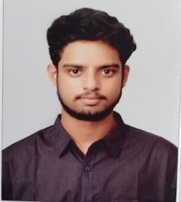West Godavari [Email:adityamekala2000@gmail.com](mailto:sushmanallam77@gmail.com) Andhra Pradesh, 534237.

Phone: +917901010301

# CAREER OBJECTIVE:

To work in an organization which can provide me with varied opportunities to expand my knowledge and improve my skills and learn and grow while working towards the organizational goals.

# ACADEMIC CREDENTIALS:

|  |  |  |  |  |
| --- | --- | --- | --- | --- |
| **COURSE** | **University/ Board** | **INSTITUTION** | **YEAR** | **CGPA/ PERCENTAGE** |
| B.Tech (ECE) | JNTU,  Kakinada | Sagi Rama Krishnam Raju Engineering College (Autonomous), Bhimavaram. | 2021 | 6.7  (up to 4-1) |
| Intermediate (MPC) | Board of Intermediate  Education | Sri Chaitanya Junior College, Vijayawada. | 2017 | 72% |
| Secondary Education | Board of secondary Education | Sri Chaitanya techno School, Bhimavaram. | 2015 | 8.7 |

**TECHNICAL SKILLS:**

* Programming Languages: c, python
* Web Technologies: HTML and CSS

# MINI PROJECT:

Car safety using ultrasonic sensor and LEDs for indication with arduino

# HOBBIES:

* + photography
  + playing cricket

# ACHIEVEMENTS:

* Member in a winning cricket team in school level
* Won first prize in essay writing competition

# PERSONAL PROFILE:

Father’s Name : M.Ganesh

Mother’s Name : M.Bhagya Lakshmi

Date Of Birth : 2-08-2000

Nationality : Indian

Gender : male Languages Known : English,Telugu

# DECLARATION:

I hereby declare that all the above-mentioned information furnished are true and correct to the best of my knowledge and belief.

**M.Aditya**